
Lab Program Number: 27 Date: 13th March,2026
Title: Preparing Linux Lab Environment
THEORY:
Linux
Linux is a free and open-source operating system that is based on Unix. It acts as a bridge between a computer’s hardware and the software applications users run. It is known for its stability, security, and flexibility. Linux is widely used in various environments from personal computers and mobile devices to servers and supercomputers. Linux is especially popular for running web servers and powering devices like routers, TVs, and smartphones. User can modify its source code, and popular distros include Ubuntu, Fedora, and Debian.
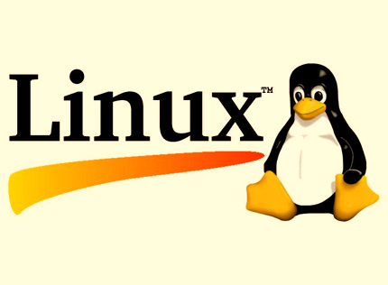
Fig: Linux OS
Virtual Box
VirtualBox is a free and open-source virtualization software developed by Oracle. It allows users to run multiple operating systems on a single physical machine by creating virtual machines (VMs). It supports various host platforms like Windows, macOS, Linux, and Solaris, making it a versatile choice for developers, students, and IT professionals.
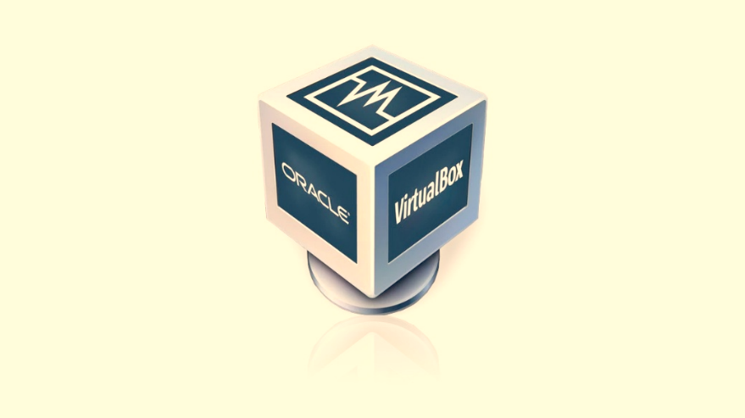
Fig: Virtual Box

VMware
VMware refers to a suite of virtualization products developed by VMware Inc., with VMware Workstation (for Windows and Linux) and VMware Fusion (for macOS) being the most used desktop virtualization tools. It is known for its robust performance, advanced features, and enterprise-level capabilities, such as better hardware integration and snapshot management
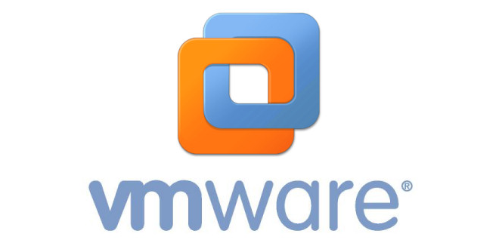
Fig: VMware
Installing Virtual Box:
Installing VirtualBox lets you run multiple operating systems at once by creating virtual machines on your computer. This is useful for testing software, developing programs, or trying out different operating systems without making any changes to your main system.
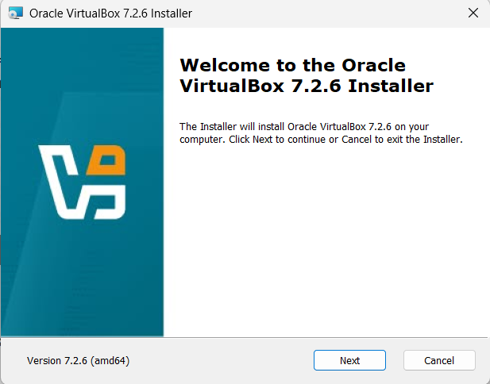

Here, Click Next and Proceed
After Virtual Box is installed, we get the interface like this,
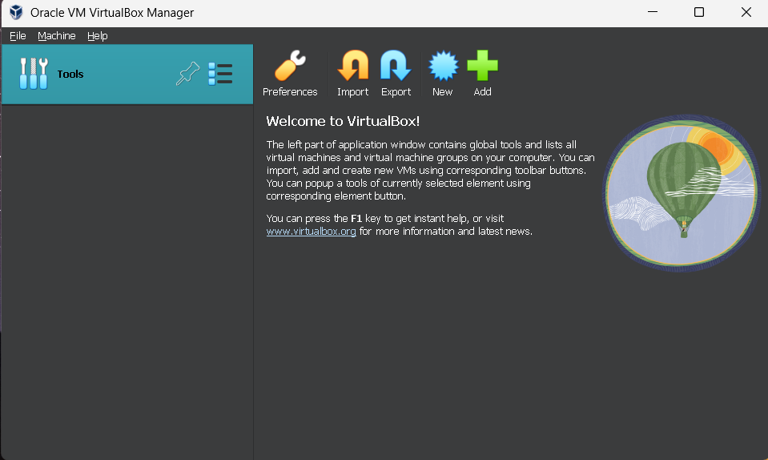
Once Virtual Box is installed, we can create, add or import new VMs using toolbar buttons.

Installing Linux (CentOs) Desktop OS:
Step 1: Click New on Virtual Machine toolbar and add details about the new VM and required OS.
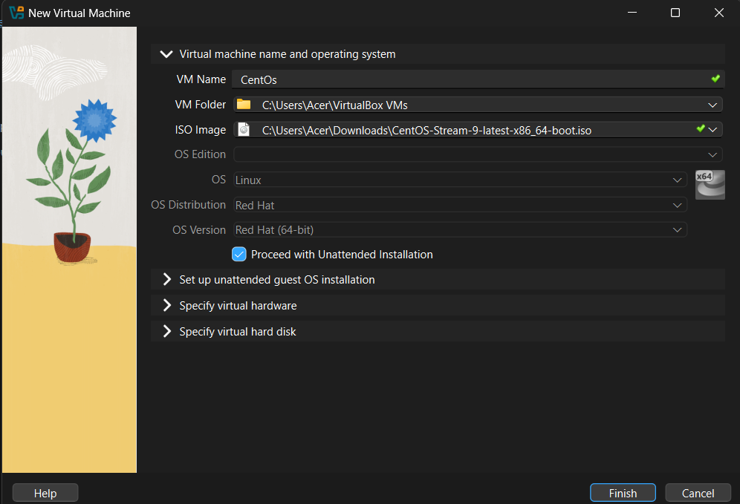

Step 2: Select the Base memory size to allocate for virtual machine.
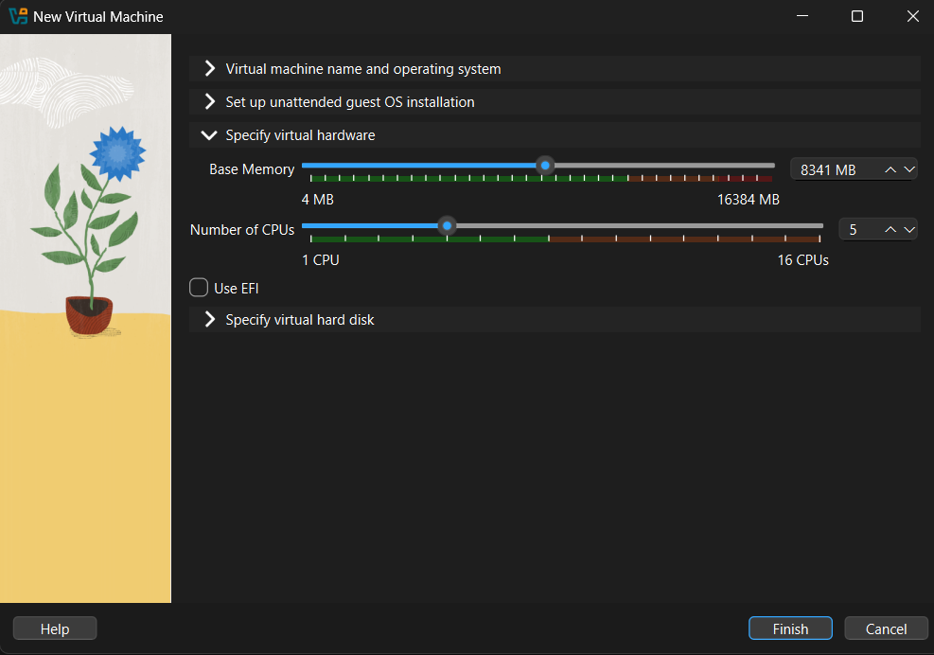
Step 3:.Select the Disk size to allocate for virtual machine
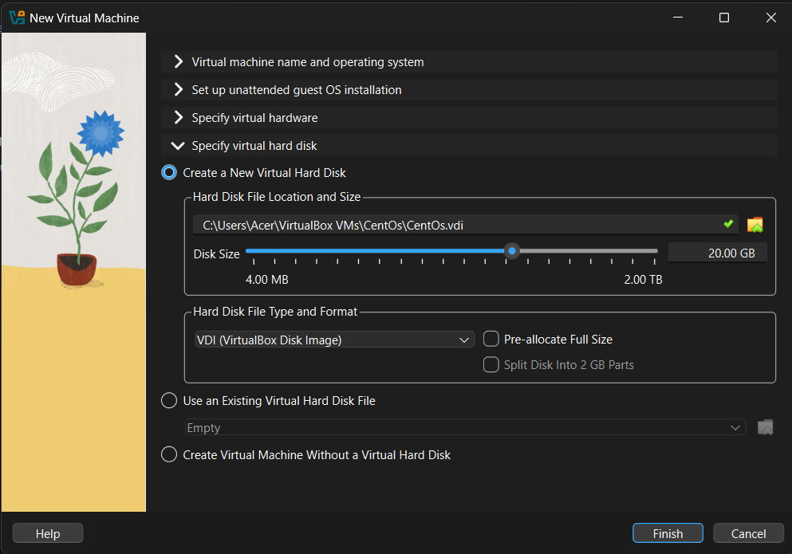

Step 4: The interface of the newly configured Virtual Machine for CentOs Desktop OS occurs then Choose the VM and click Start to launch it.
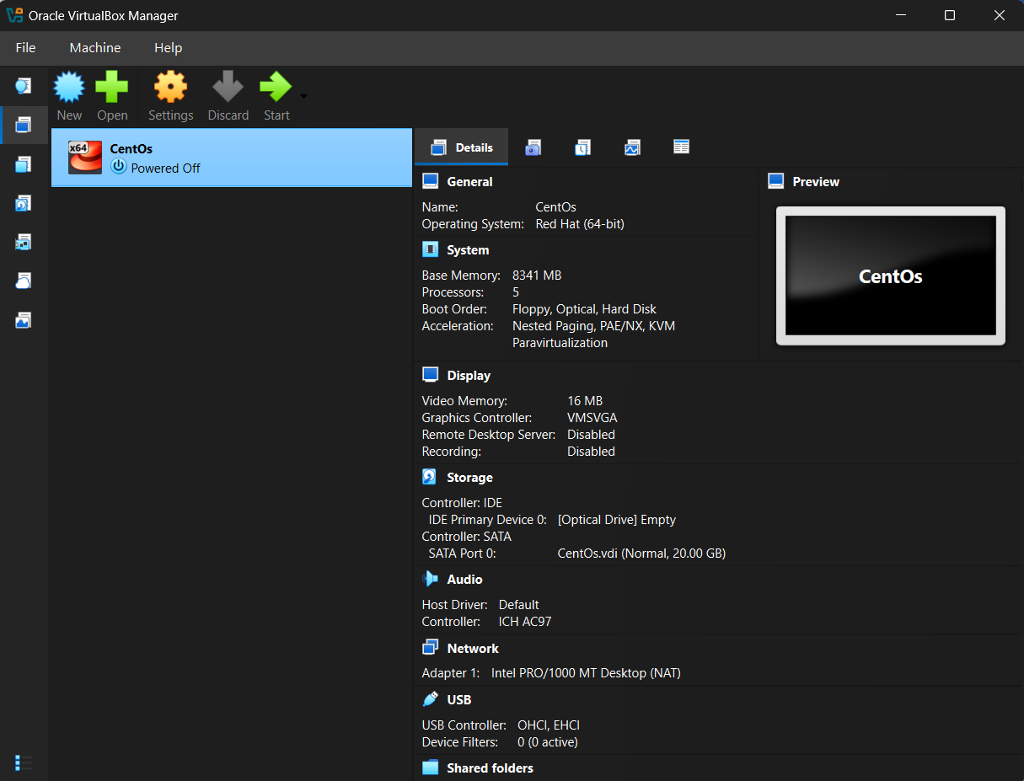

Step 5: Select the preferred Language.
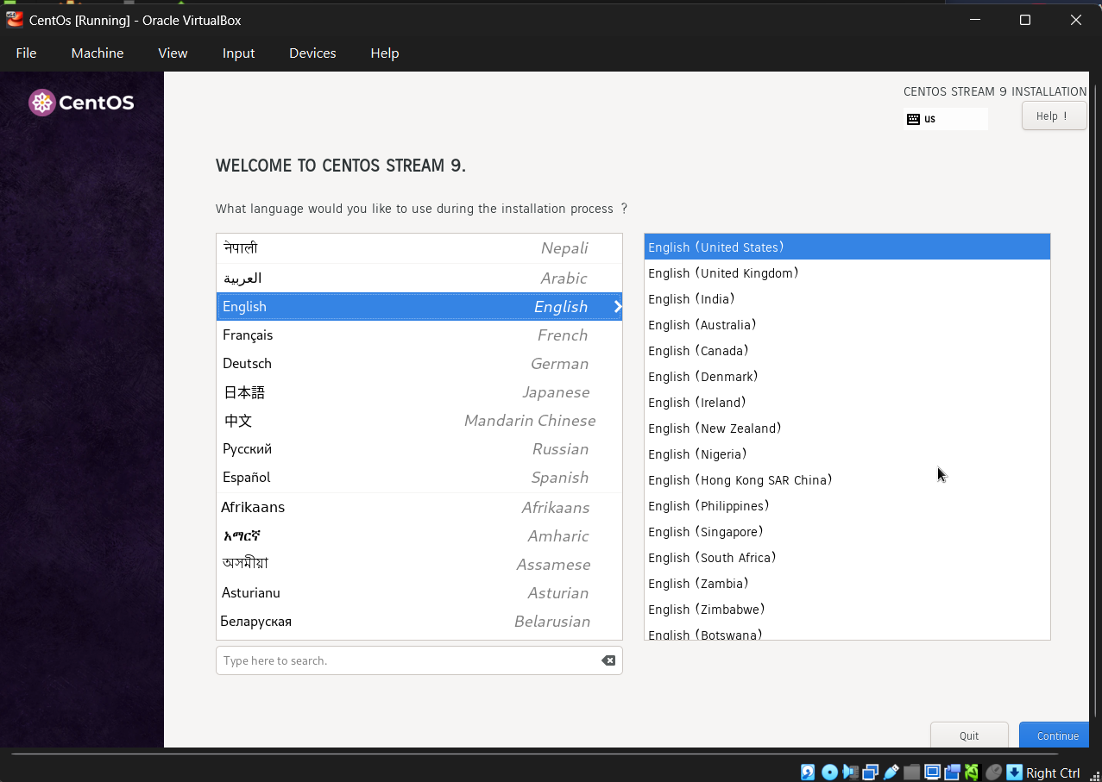

Step 6: Now enter the Login details on the screen and press Enter to login
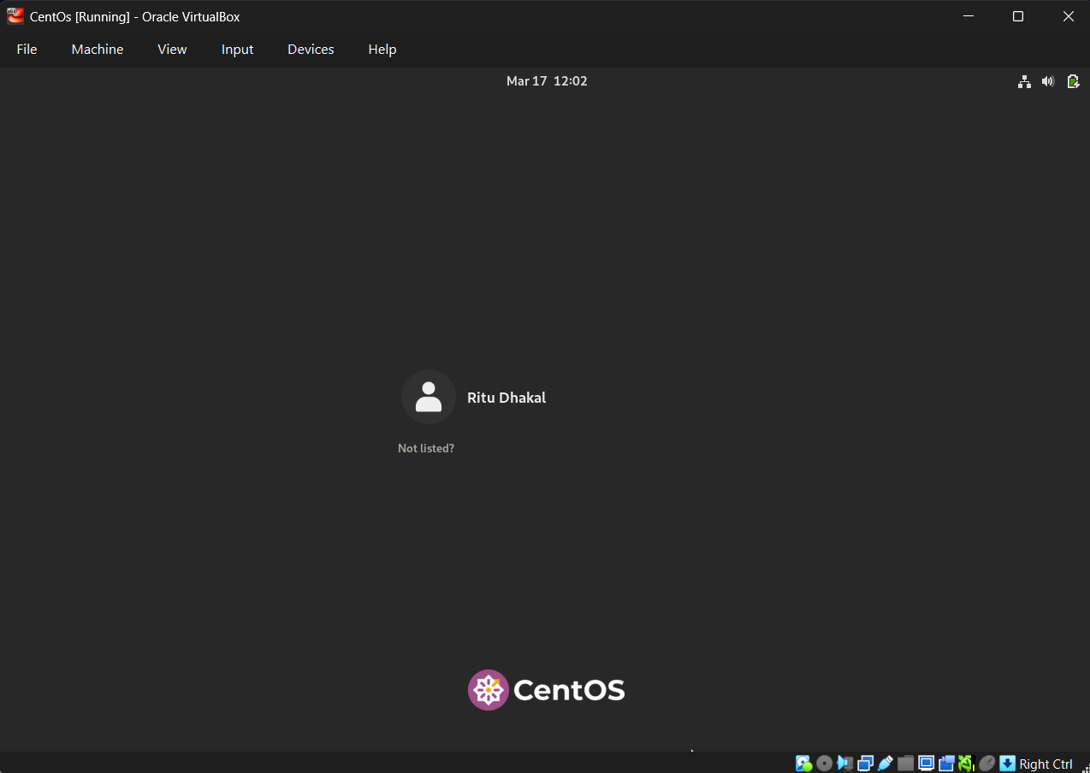
Step 7: Now our System is ready and CentOS is installed completely.
